**Create a simple computer program to meet a set brief**

US18740 Version 6 Level 2 Credits 3

**Plan:**

**For:** This program is for the person in charge of the cash register.

**Purpose:** For the user to enter item prices (one at a time) of shop items, and have a cash register slip printed for their prices. The printed cash register slip will contain total price, discount amount, final price, number of items, the most expensive item and the average price paid.

**Computer Language:** Python 3.5

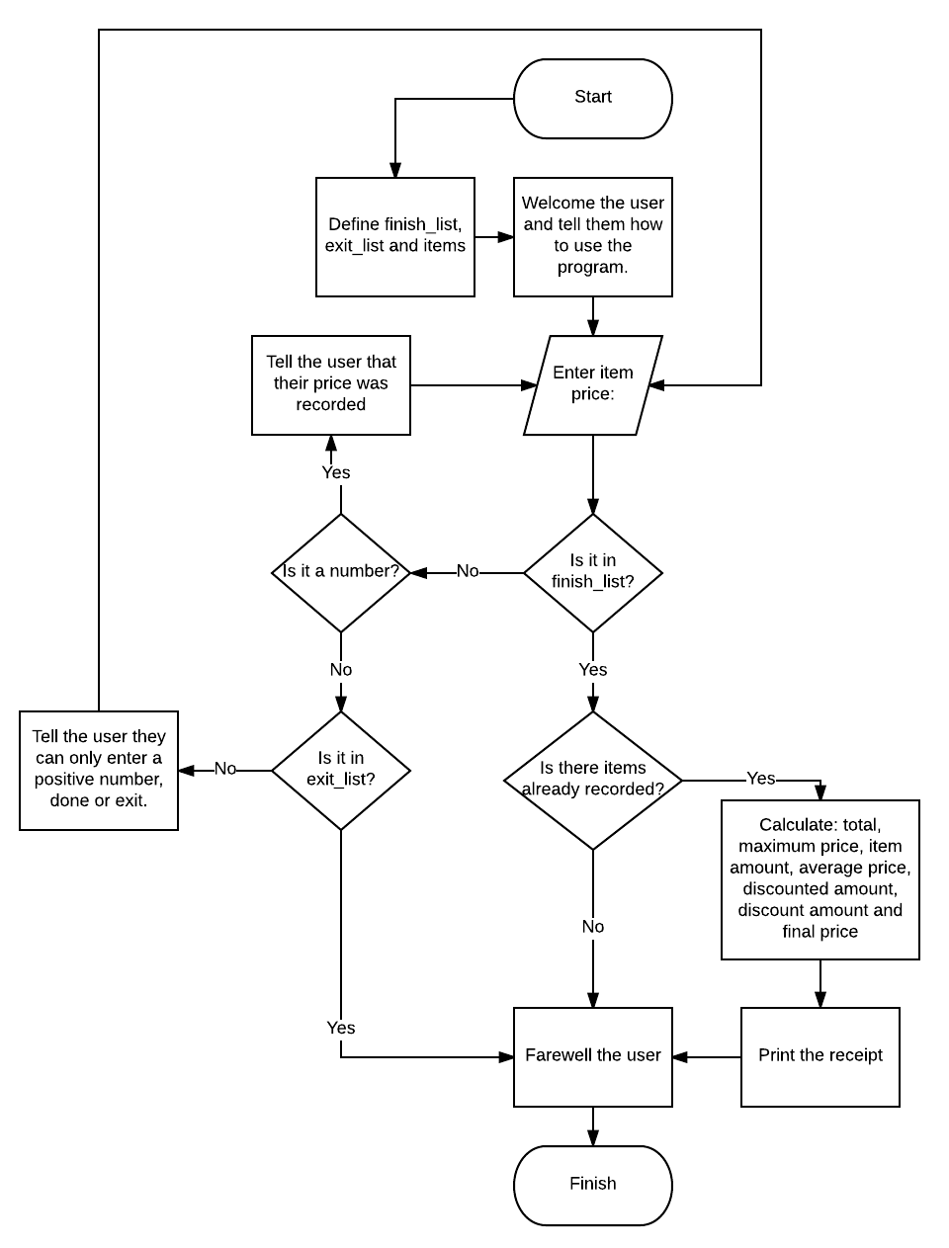**Flowchart:**

**Input:** Must be an integer or float

**Output:** cash register slip

**Layout (Pseudocode):**

isfloat(number)

try to return number as a float

except, return False

discount(percent, total)

if total price is greater than $100:

return final price, discounted amount and percent

else:

return False

register_slip (items)

Calculate total of items

Calculate maximum price of items

Calculate average price of items

Calculate discount percent from discount

Calculate discount amount from discount

Calculate final price from discount

return calculations

main

declare items as a list

welcome

Start of infinite loop

Item price input

Check if input is an integer or float

if True:

is input 0?

if True:

if something in items (list):

get data from register_slip

print formatted register_slip

break loop

is input greater than 0?

if True:

add price to items (list)

else:

user must enter positive number

go back to the input

else:

user must enter positive number or 0

go back to the input

leave



**Functions:**

**isfloat(number)**

For checking and converting ‘number’ into a float.

*returns float(number) or False*

**discount(percent, total)**

For checking if a discount can be applied.

*returns the final price, discount amount and discount percent or False.*

**register_slip(items)**

For calculating all the data needed for the cash register slip.

*returns total, final price, discounted amount, item amount, maximum price and average price.*

**Procedures:**

**welcome()**

For welcoming the user.

**leave()**

For thanking the user for coming.

**main()**

Start of the program which will start a loop, get input, run tests on input and then output a cash register slip.

**Lists:**

**finish_list:** contains a list of ‘finish’ commands the user’s input will be compared against.

**exit_list:** contains a list of ‘exit’ commands the user’s input will be compared against.

**items:** contains a list of all the valid prices entered by the user.

**Variables:**

**item_price:** user input

**total:** sum of all valid floated user inputs

**percent:** discount percentage

**discounted_amount:** amount taken off the original price

**final_price:** total price less the discounted amount

**item_amount:** number of items entered by the user

**maximum_price:** highest price entered by the user

**average_price:** average of all the prices entered by the user

**number:** argument of the isfloat() function for float checking and converting.

**Stakeholder consultations:**

Can this program handle refunds.

Yes if value is input as negative

Can I allow the user enter ‘finished’ or ‘done’ to get the cash register slip as well as ‘0’?

* Yes

Can I allow the user to enter ‘exit’ or ‘x’ to quit the program (without printing a cash register slip)?

* Yes

Should I tell the user that their price was recorded if it was valid?

* Yes it will ensure clarity

**Milestones:**

Date Started: 08/05/2017

Date: 08/05 – Attempted a single line input version but scraped it in favour of a multi-line input version.

Date: 10/05 – Stakeholder consultation #1: I can allow the user to enter ‘done’ or ‘finished’ to get the cash register slip (other than ‘0’).

Date: 12/05 – Stakeholder consultation #2: I can allow the user to enter ‘exit’ or ‘x’ to exit the program.

Date: 15/05 – Stakeholder consultation #3: I can now tell the user that their price was recorded (if it valid).

Date: 1/06 – Fixed rounding issue with average price.

Date Finished: 01/06/2017

**Testing procedures:**

Some of the testing procedures that I used are:

* I checked my program with various different inputs such as negative integers and floats, strings and special characters. So that only integers and float values are accepted. The only strings that I allowed to be entered were ‘exit’, ‘x’, ‘finished’ and ‘done’, for exit and finished values there were test cases.
* I checked if the total amount was over $100.00, if it was then I returned the discount percent, discount amount and discounted price.

**Resources used:**

Documents provided by the teacher

www.stackoverflow.com

https://docs.python.org/3.5/

**Testing:**

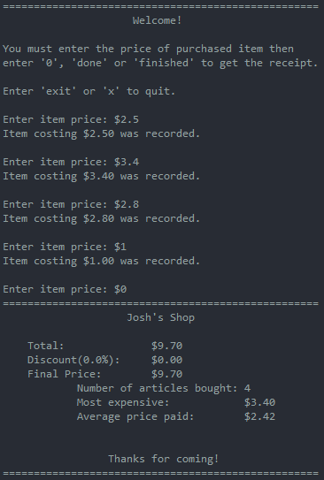**Test 1:**

Input: 2.5

3.4

2.8

1

0

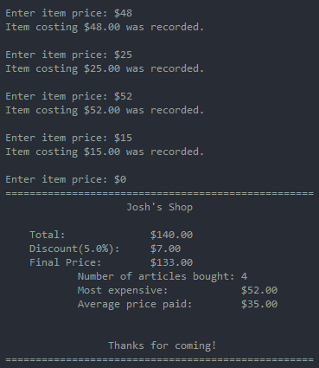**Test 2:**

Input: 48

25

52

15

0

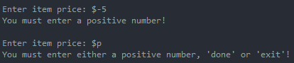

**Test 3:**

Input: -5

p

**Test 4:**

Input: 0